2020 Summer Camps @ River Chase Equestrian Center

Team of Professional Instructors and Awesome Working Student Helpers *Indoor Arena for All Weather Riding

Campers will each be assigned their own Horse/Pony on Monday and learn all aspects of caring, maintenance and riding their horse/pony for the week. Campers will ride 2x/day and on Friday compete in a show to show off what they have learned. Prizes will be awarded for everything from best groomed to most improved rider-horse/pony combo. Fun for all Ages and Levels!!

Cost $375/week 9am-5pm (Early/Later Hours available for Additional Fee)
Limited Space Available – Email Now: Info@riverchasefarm.com
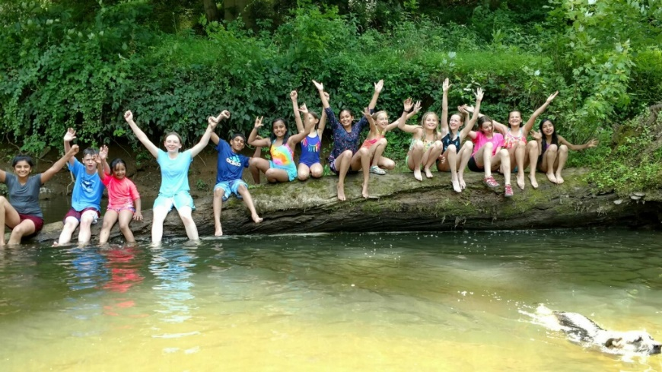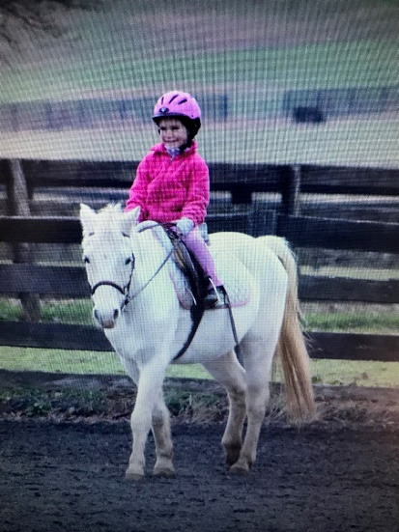

Dates Available: 6/15-6/19, 6/29-7/03, 7/13-7/17, 7/27-7/31, 8/03-8/09

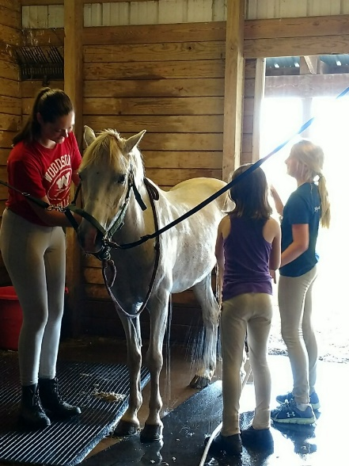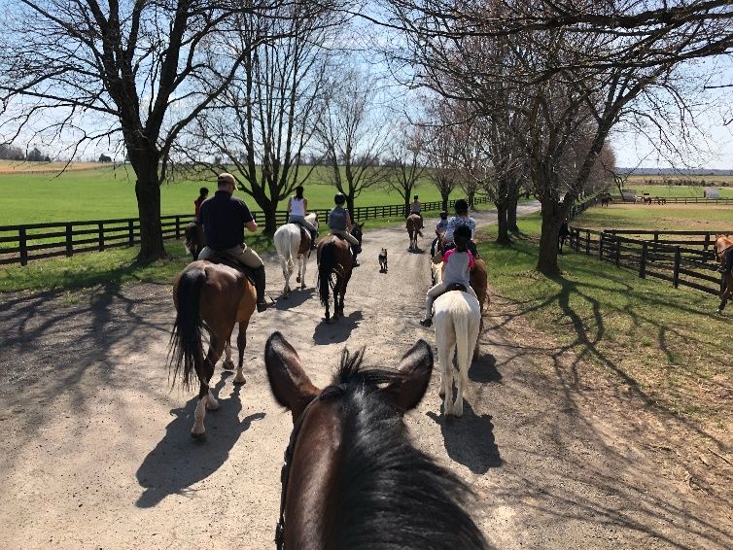

Voted Best of Aldie 2015,2016,2017,2018 and 2019 Voted Best Of Loudoun 2018 Final 3 2019 and 2020
